**PROJECT REPORT**

**PROJECT TITLE:**

Estimation and prediction oh hosptlization and medical care costs.

**TEAM ID:** LTVIP2023TMID00968

**TEAM SIZE:** 5

**TEAM LEADER:** CHAPA MOUNIKA

**TEAM MEMBER:** BATCHU VINEELA

**TEAM MEMBER:** BODDAPATI DILEEP

**TEAM MEMBER:** BOJJA MANIDHAR PAVAN

**TEAM MEMBER:** CHINTALA SOMESH

**FACULTY MENTOR:** HYMAVATHI

**1.INTRODUCTION**

Estimation and prediction of hospitalization and medical care costs play a crucial role in healthcare planning , financial management and resource allocation.

By accurately forcasting these costs , healthcare provides , polymers, insurance companies, and patients can make informed decisions and develop effective strategies to manage healthcare expenses.

Overall , accurate estimation and prediction of hospitalization and medical care costs can significantly benefits healthcare stakeholders in making well-informed decisions , optimizing resource allocations and improving patient outcomes.

* 1. OVERVIEW :-

Estmation and prediction of hospitalization and medical care costs is a data analytics project focused on analyzing and forcasting the expenses associated with hospitalization and medical treatments . The primary goal is to develop models that can accurately estimate the cost incurred by patients and health care providers for various medical procedures.

Data collection and preprocessing:-

A comprehensive dataset was collected from Kaggle which includes age,sex,region,charges,smoker and BMI . The collected data uder went through preprocessing to handle missing values, remove,inconsistencies and ensure data quality.

CREATING A FLASK WEB APPLICATION :-

For estimation and prediction of hospitalization and medical care costs data involves building an interface where we can input revelant information and the application will use the predictive model to estimate the medical care costs.

* 1. PURPOSE:-

The estimation and prediction of hospitalization and medical care costs project playes a vital role in data -driven decision – making , cost optimaization and improving patient care in the healthcare industry. It empowers various stakeholders with actionable insights to make informed choice and enchances the overall efficiency of the healthcare system.

By understanding the estimation and prediction of hospitalization and medical care costs project, several significant achivements and benefits can be realized in the healthcare industry and beyond.

Key outcomes:-

* Cost optimization .
* Improved financial planning.
* Transparency and Infomed decision making.
* Encahnced patient care.
* Tailored insurance coverage.

**2.LITERATURE SURVEY**

The prevelance of The obesity , which is defined as body mass index (BMI) greater than 30,has be increased dramatically in the inited states since late 1990s.

So much so that recently obesity has been officially recognized as a disease by the American medical assosoation , an action that could put more emphasis an the health condition by the American medical association, an action that could put more insurance companies to minimize its adverse effects. Currently, rates of obesity exceed 30% in most sex and adults age groups , whereas its prevelance among children and adolescents , defined as a BMI of more that the 95th percentile, has reached 17%.

The alarming rates of high prevelance of abesity have posed a significant public health concern as well as a substantial financial burden on our society because obesityis know to be a risk factor for many chronic disease, such as type 2 diabetes , myocardial infraction, cancer, hypertension,asthma, smoke and other conditions.

To understand the economic burden of obesity, several studies have attemted to estimate the attributable costs of obesity, following the burden cost-of-illness study estimated that healthcare spending attributable to the rising prevalence of obesity has increased by 27% between 1987 and 2001.

2.1 EXISTING PROBLEM:-

Solving the estimation and prediction of hospitalization and medical care costs involves a systematic approach that combines data analysis,model development and evaluation.

* Actuarial Analysis:-

Actuarial uses mathematical and statistical methods to analyze healthcare costs,predict risk and set insurance premiums.

* ECONOMIC MODELING:-

Applying economical principles to estimate healthcare costs and the impacts of various interventions (or) policy changes.

* HEALTH RISK ASSESSMENT MODELS:-

These models estimate the likelihood of future health events (hospitalization , higher medical costs) for individual patients , helping insurers (or) healthcare provides tailor interventions and care plans.

* VALUE -BASED CARE MODELS:-

These models aim to improve patient outcomes while controlling costs,offen involving payment systems that reward healthcare provides based on patient outcomes.

* SIMULATION AND MONTE CARLO METHODES:-

Simulation technique can be used to model the complexities of healthcare systems and predict future cost based on different scenarios.

* COST PREDICTION TOOLS AND SOFTWARE:-

Some hospitals and healthcare organisations use specialized software and tools that leverage historical data and machine learning algorithums to predict costs for specific medical procedures (or) conditions.

2.2 PROPOSED SOLUTION:-

Proposing a obtain for the estimation and prediction of hospitalization and medical care costs involves a combination of data-driven techniques, advanced analytics and domain expertise . collect comprehensive and diverse data related to hospitalization and medical care costs from various sources, including electronic health records , insurance claims and administrative database . The success of the proposed solution depends on the availability of quality data, collabration with healthcare experts and a commitment to continuous improvement based on real-world feedback. Healthcare caost estimation and prediction are complex tasks and a multi disciplinary approach is crucial for achieving accurate and reliable results.

* PREDICTIVE MODELING:-

Use machine learning techniques to build predictive models regression models, such as linear regression, can be used to estimate the relationship between cost be used to estimate the relations between cost and various factors essemble methods like random forcast or gradientboosting can capture complex interaction features deep learning models like neural networks can also be employed for this task.

* FEATURE IMPORTANCE ANALYSIS:-

Detemine which features have the most significant impact on cost predictions . this analysis can help identity critical factors driving medical expenses.

* COST ESTIMATION:-

Given new patient information , apply the predictive models to estimate their hospitalization and medical care costs. The model should consider both direct medical costs and indirect costs.

* MODEL EVALUTION:-

Assess the performance of the predictive models using metrices such as mean absolute error (MAE) root mean squared error(RMSE) or R-squared to guage how well the models predict costs compared to actual values.

* CONTINUOUS MODEL IMPROVEMENT:-

As more date becomes available , retrain the modls periodically to ensure they remain accurate and up-to-date.

**3.THEORITICAL ANALYSIS**

3.1 BLOCK DIAGGRAM:-

Cretaing a detailed block diagram for estimation and prediction of hospitalization and medical care costs involves braking down the process into key steps and components . Below is a high-level block diagram outlining the main stages and elements involved in estimating and predicting hospitalization and medical care costs.

The block diagram illustrates the end-to-end process of estimating and predicting hospitalization and medical care costs , starting from data collection and preprocessing to deploying the final models for cost estimation and future cost prediction.

The block represents the use of predictive models built during analysis and modelling stage to estimate and predict hospitalization and medical care costs for different scenarios.

|  |
| --- |
| Literature survey social or business impact specift the business problem business requirments. |

**ESTIMATION AND PREDICTION OF HOSPITALIZATION AND MEDICAL CARE COSTS OF THE BLOCK DIAGRAM**

|  |
| --- |
| Problem understanding |

|  |
| --- |
| Download data set from Kaggle. |

|  |
| --- |
| Data collection |

|  |
| --- |
| Logged into IBM cognos analytics and created data module. |

|  |
| --- |
| Data preparation |

|  |
| --- |
| Data visualisation |

|  |
| --- |
| Created several unique visualisations. |

|  |
| --- |
| Dashboard |

|  |
| --- |
| Created medical care costs Dasboard |

|  |
| --- |
| Story |

|  |
| --- |
| Guided journey slideshow. |

|  |
| --- |
| Visualisations with detailed information. |

|  |
| --- |
| Report |

|  |
| --- |
| Dashboard, report, story was deployed into UI with flask. |

|  |
| --- |
| Web integration |

**3.2** SOFTWARE / HARDWARE DESIGNING

SOFTWARE REQUIRMENTS:-

* IBM cognos analytics tool.
* Flask.
* Integrated development[ IDE] – spyder

HARDWARE REQUIRMENTS:-

* Minimum system requirments [RAM-4 GB, quad core processor (or) above].
* Storage.
* Graphics processing unit(GPU).

**4.RESULT**

**DATA VISUALISATIONS:-**

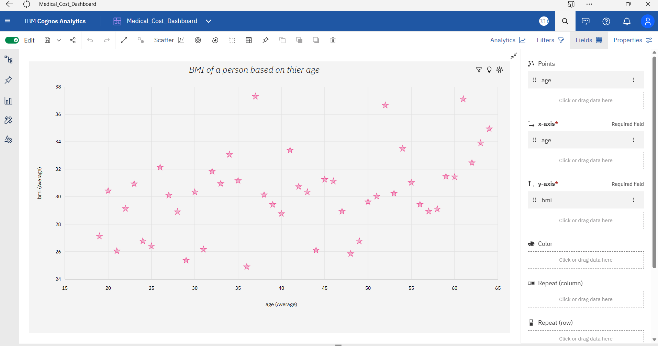

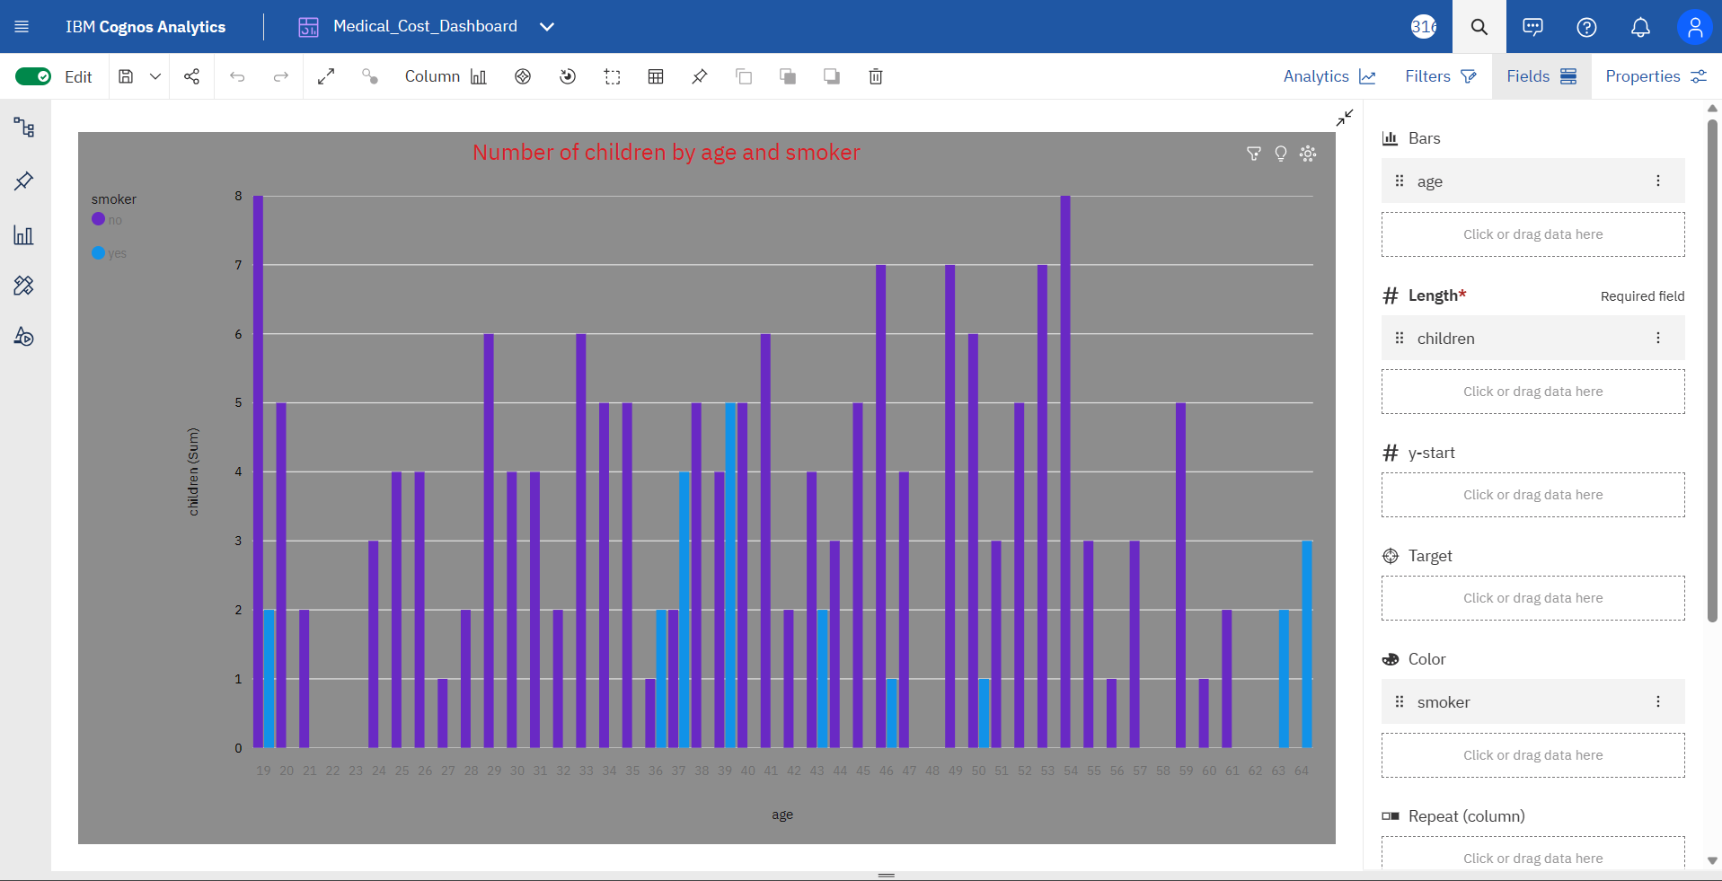

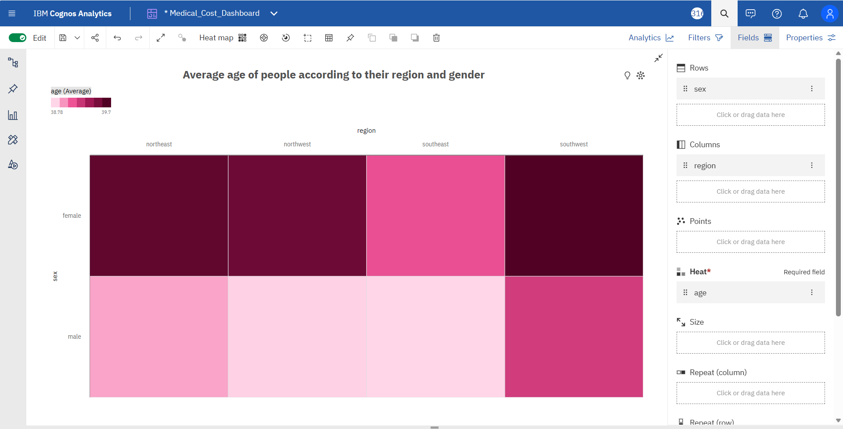

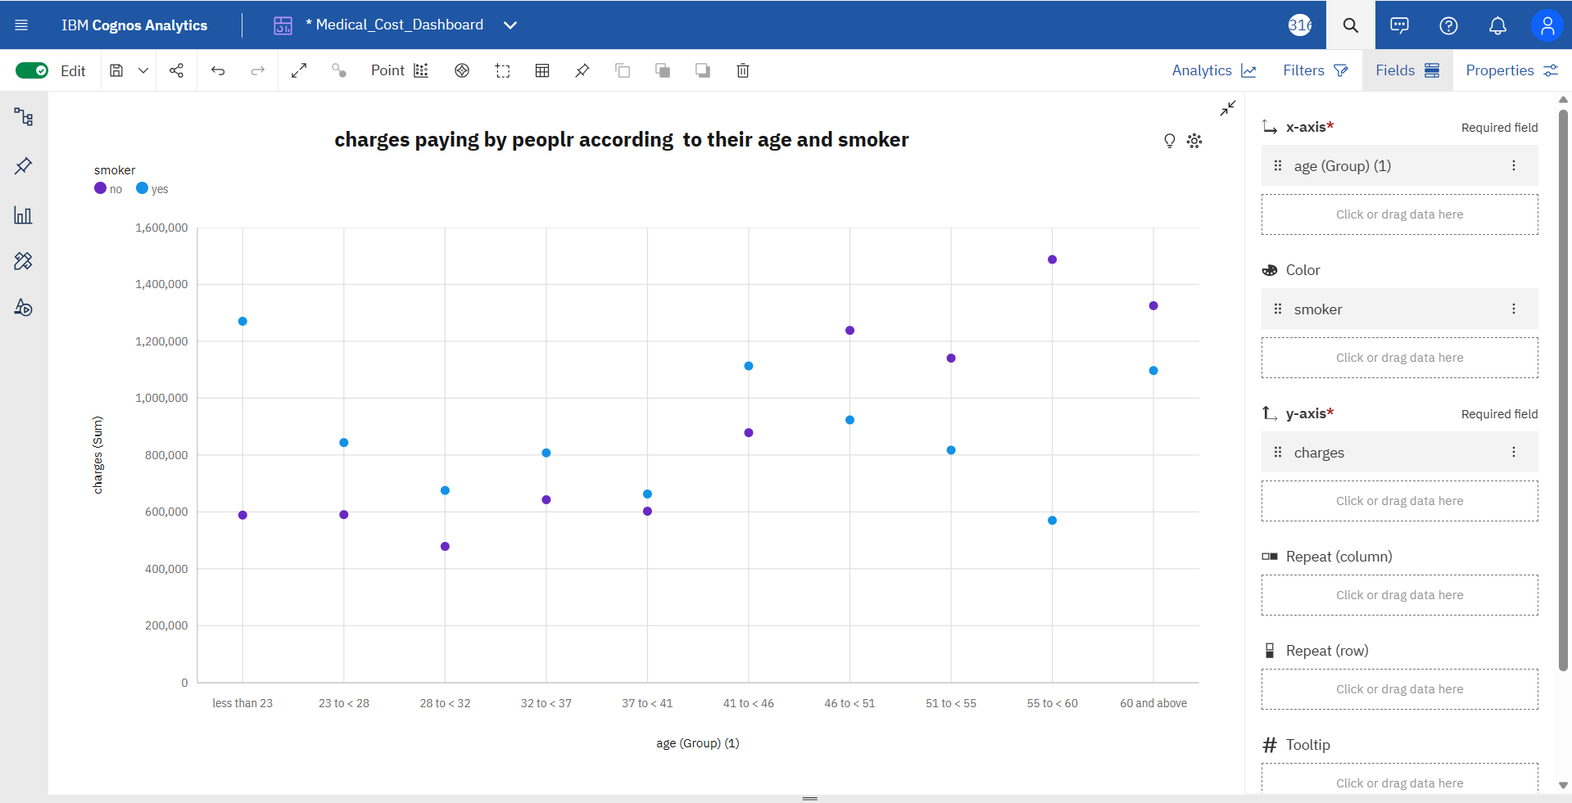

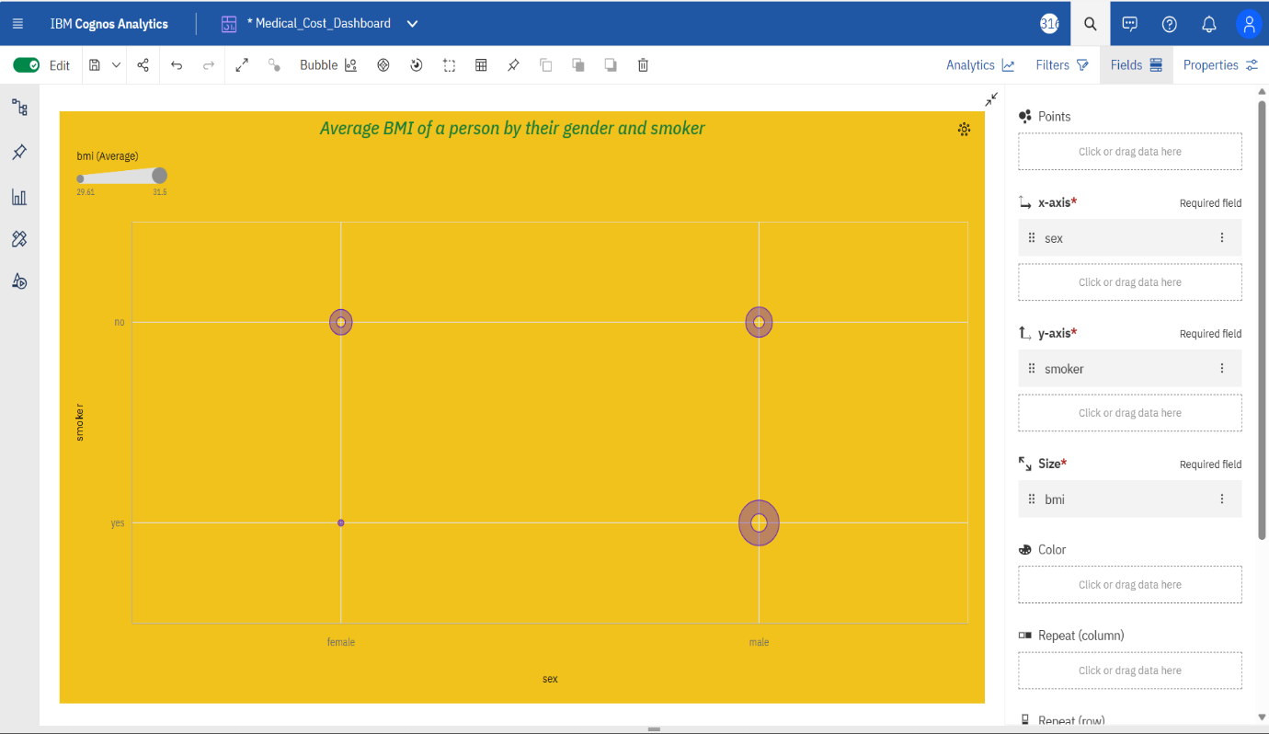

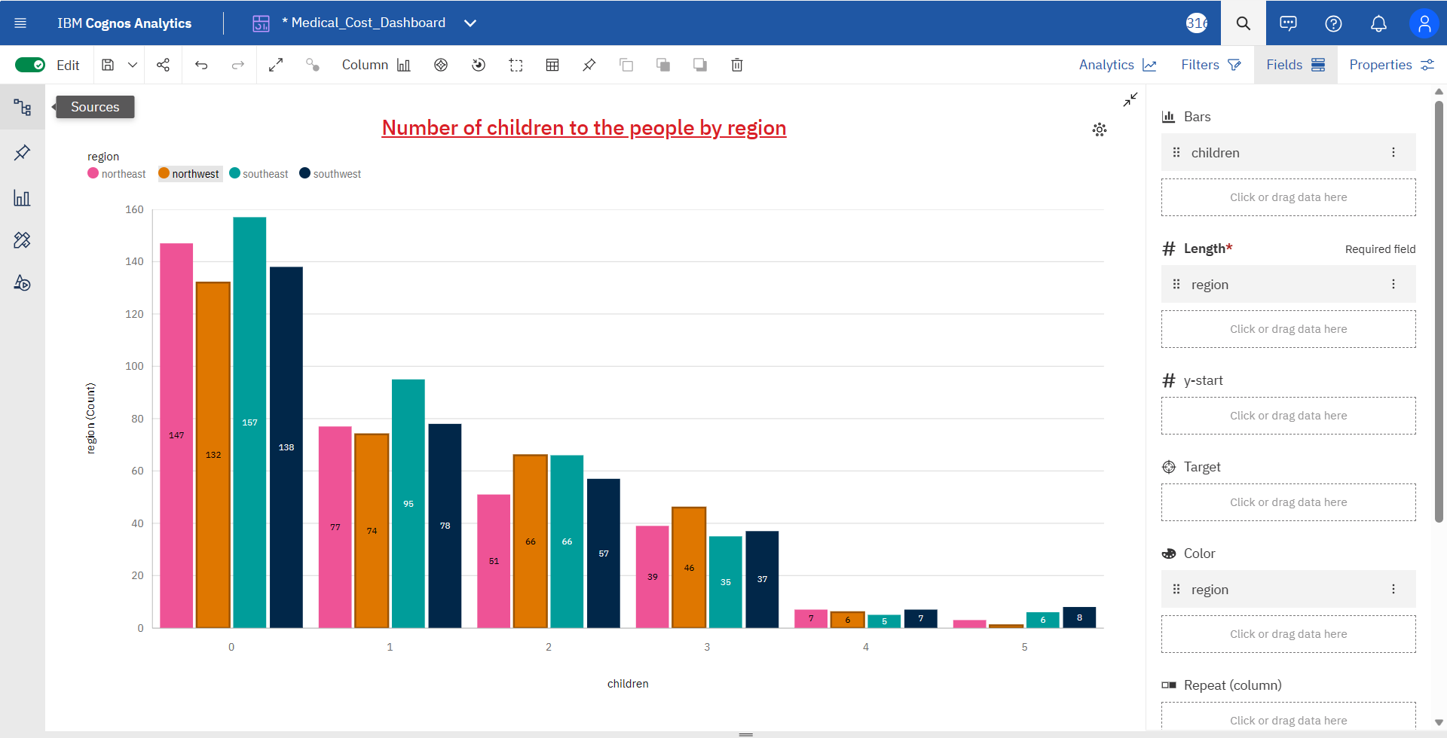

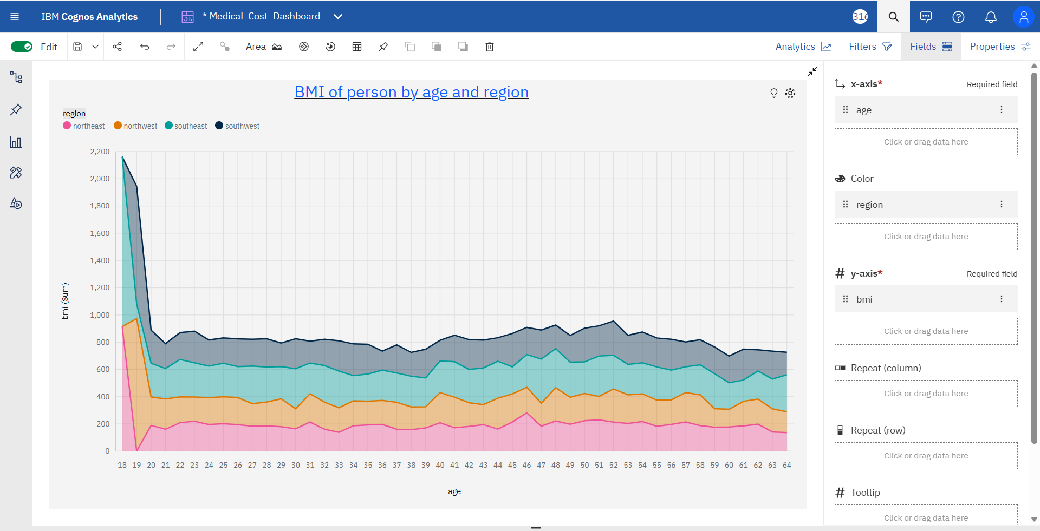

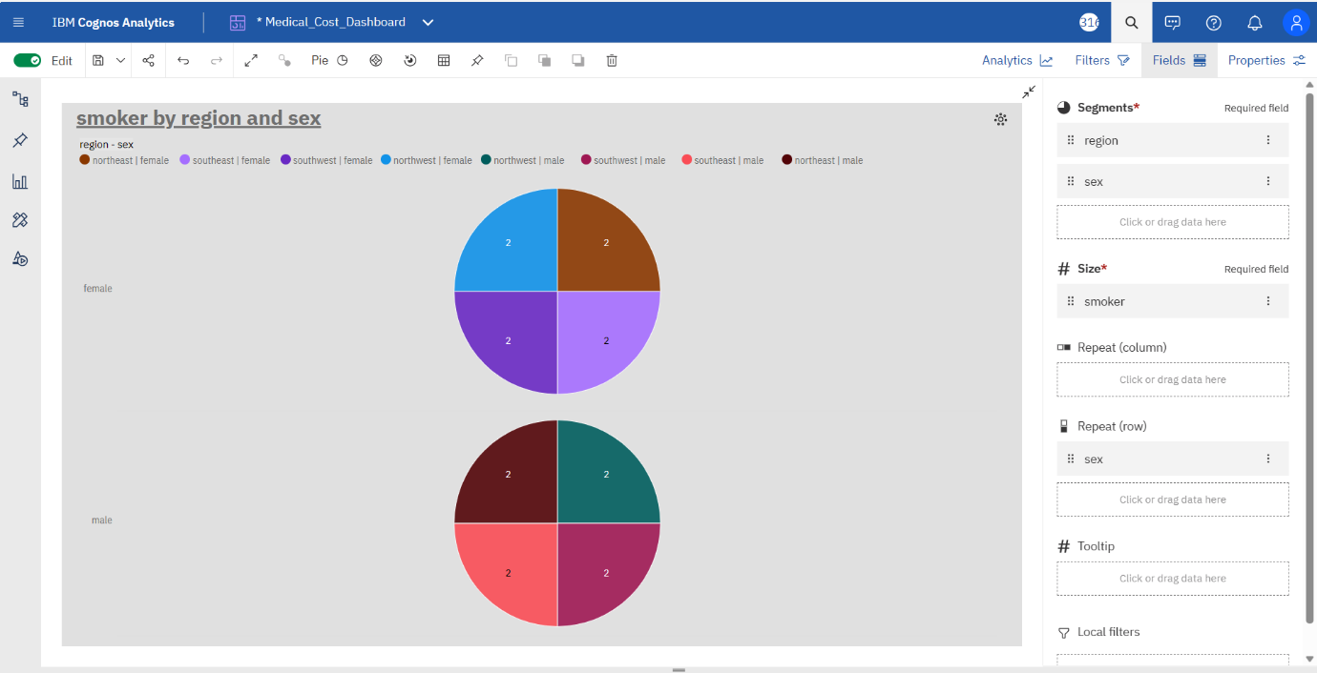

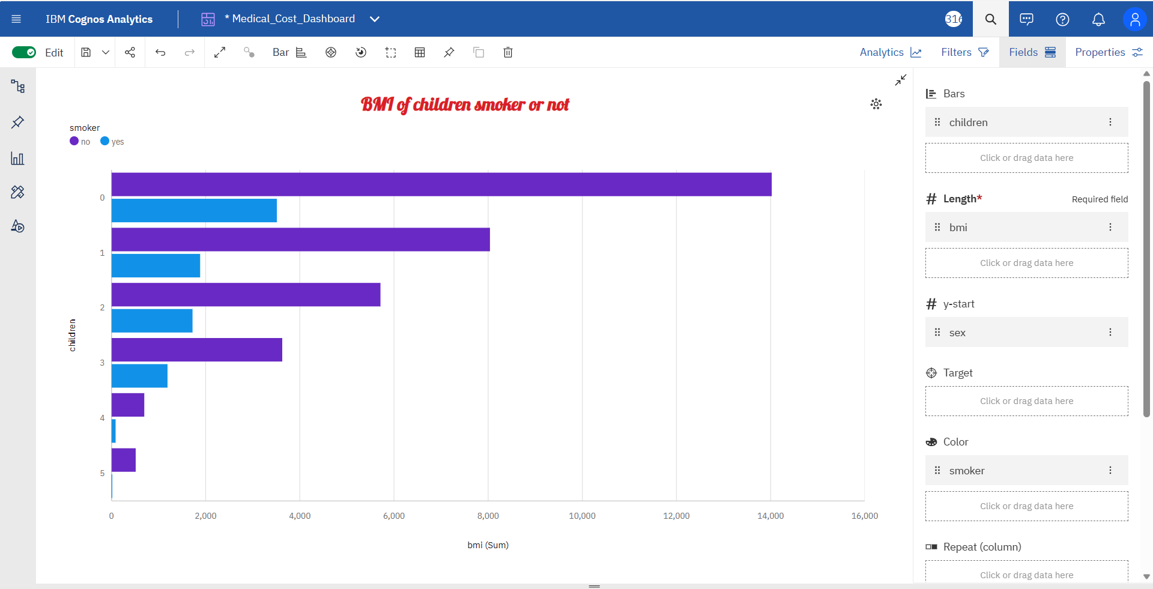

**MEDICAL CARE COSTS DASHBOARD**

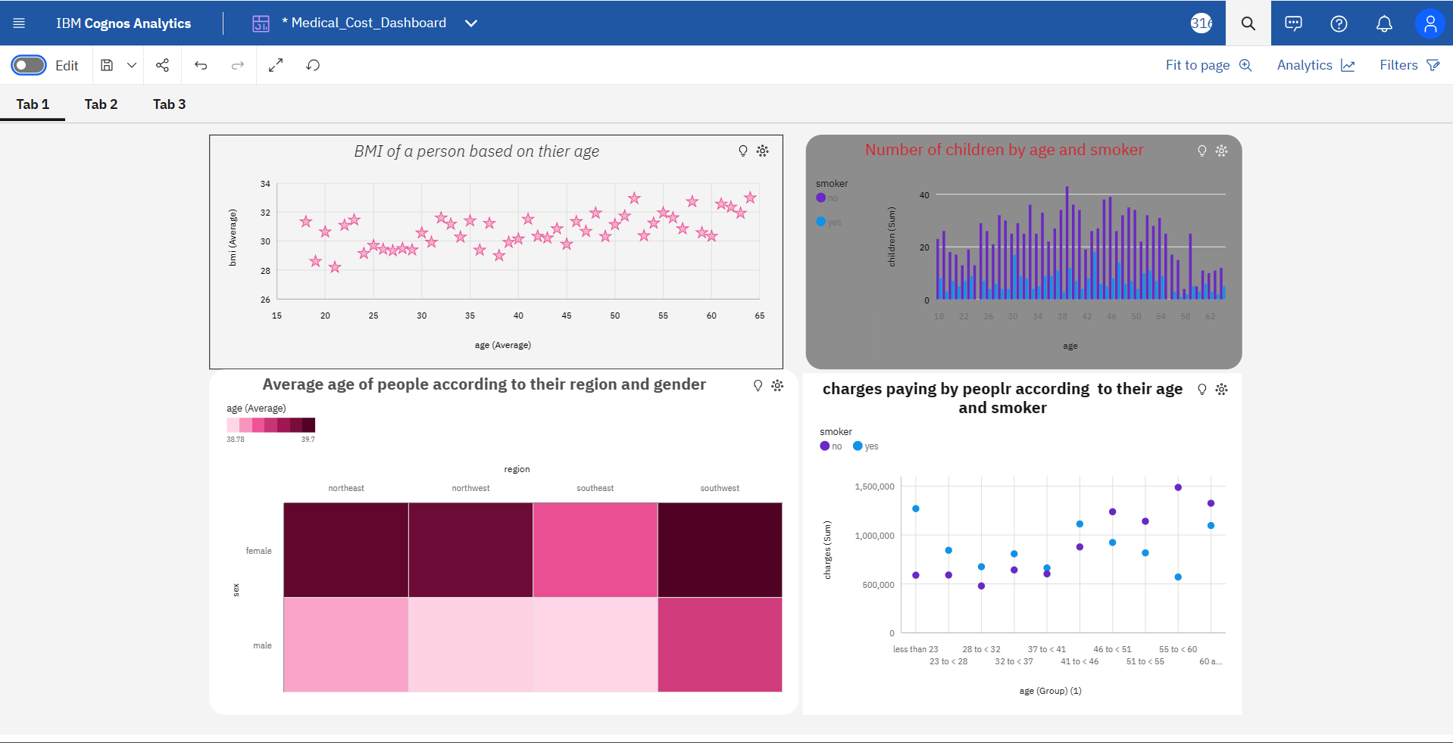

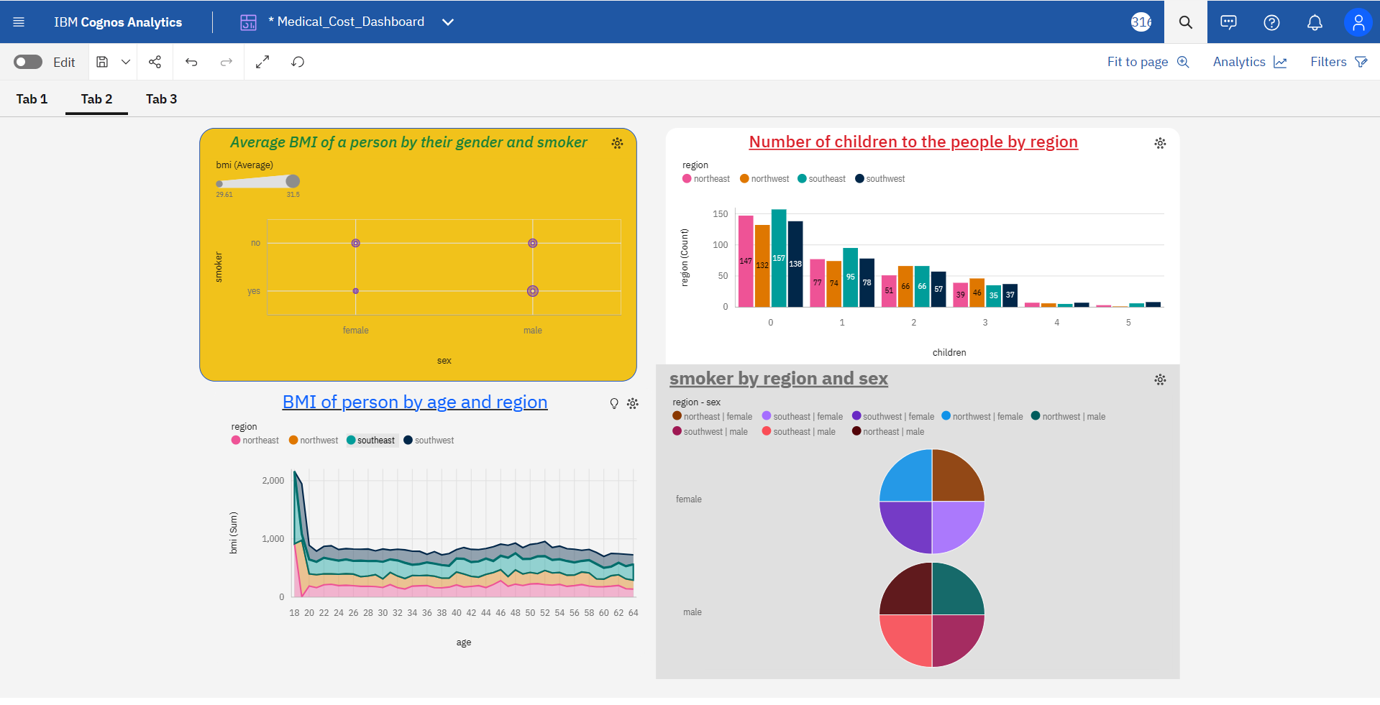

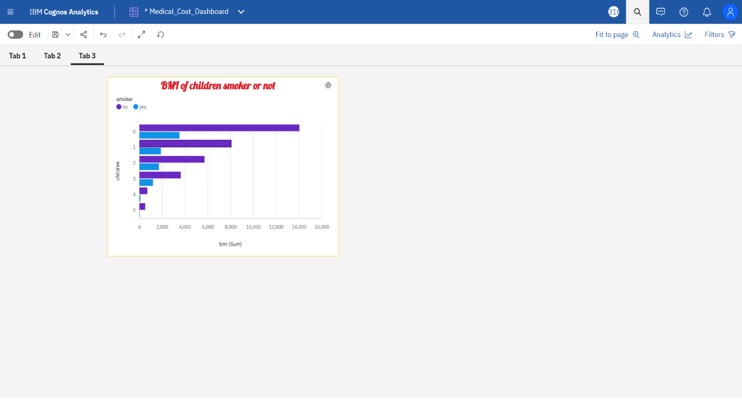 **REPORT**

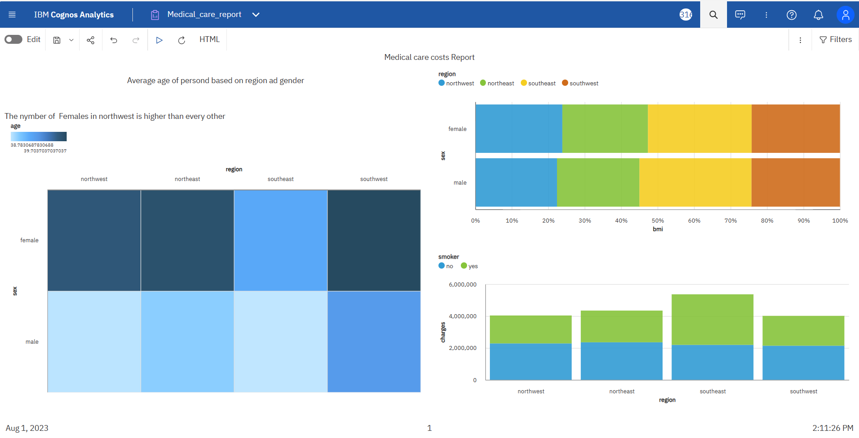

**STORY(SLIDESHOW):-**

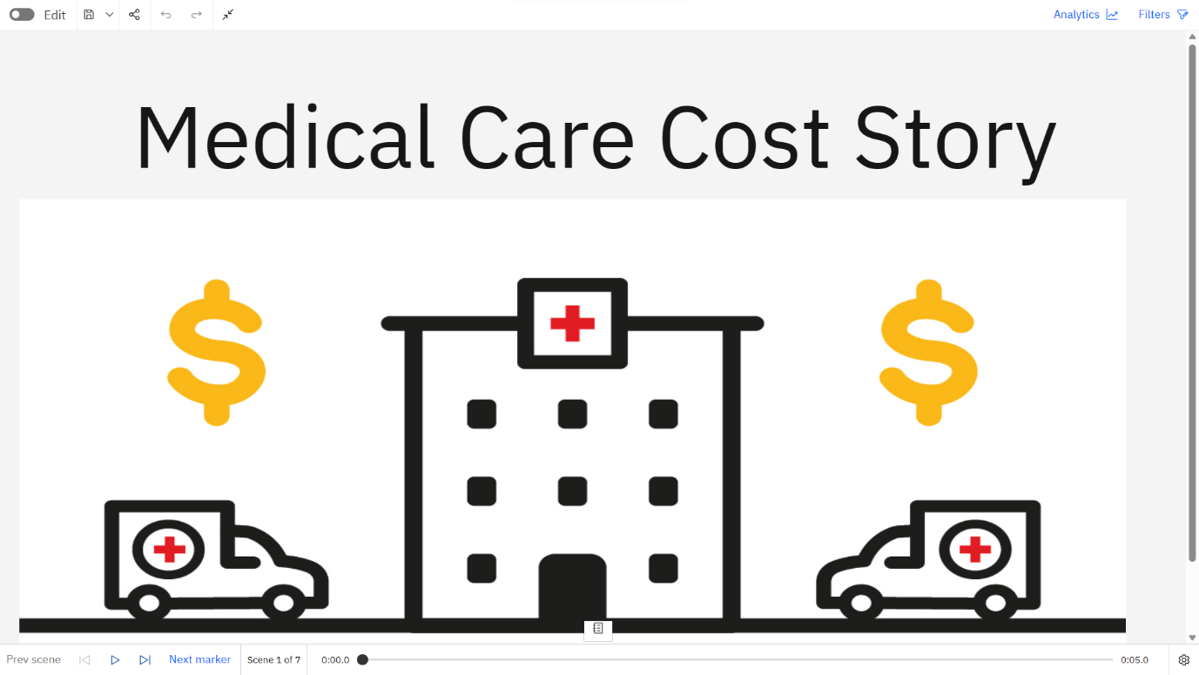

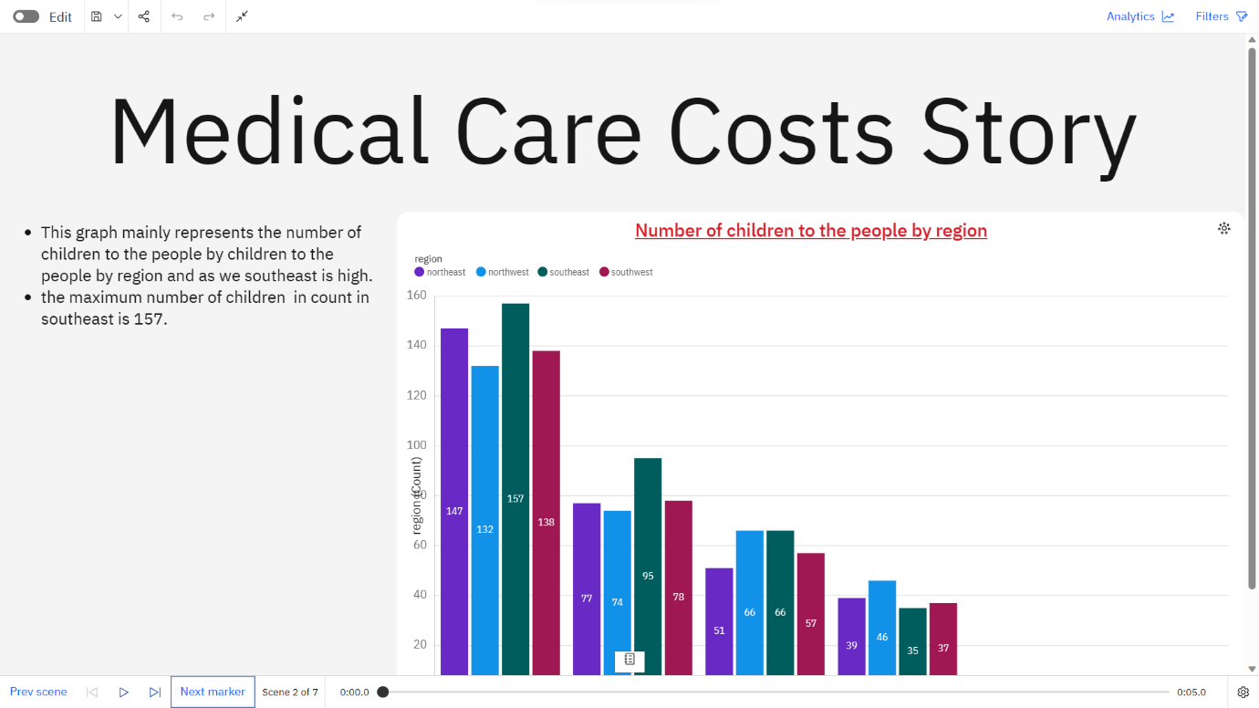

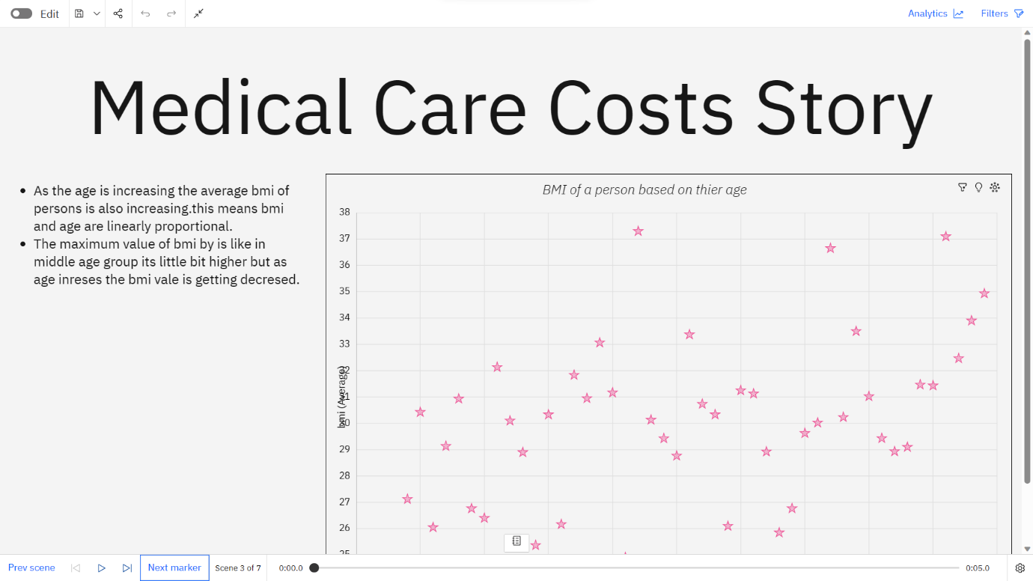

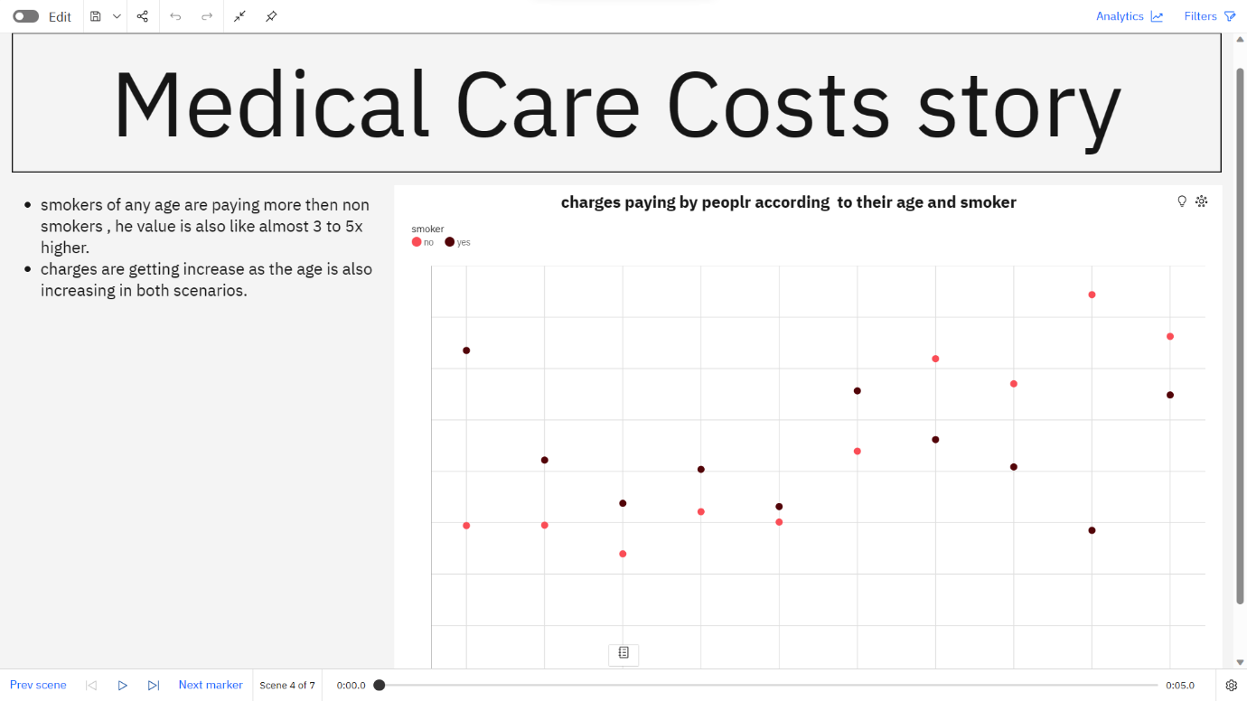

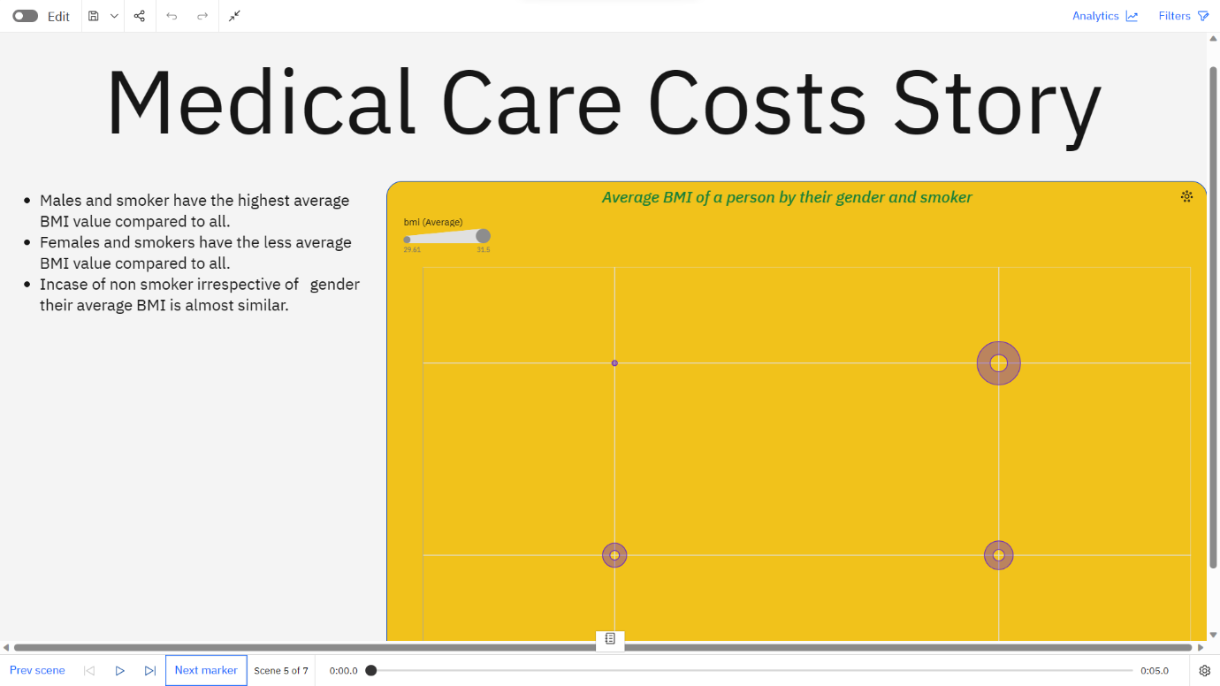

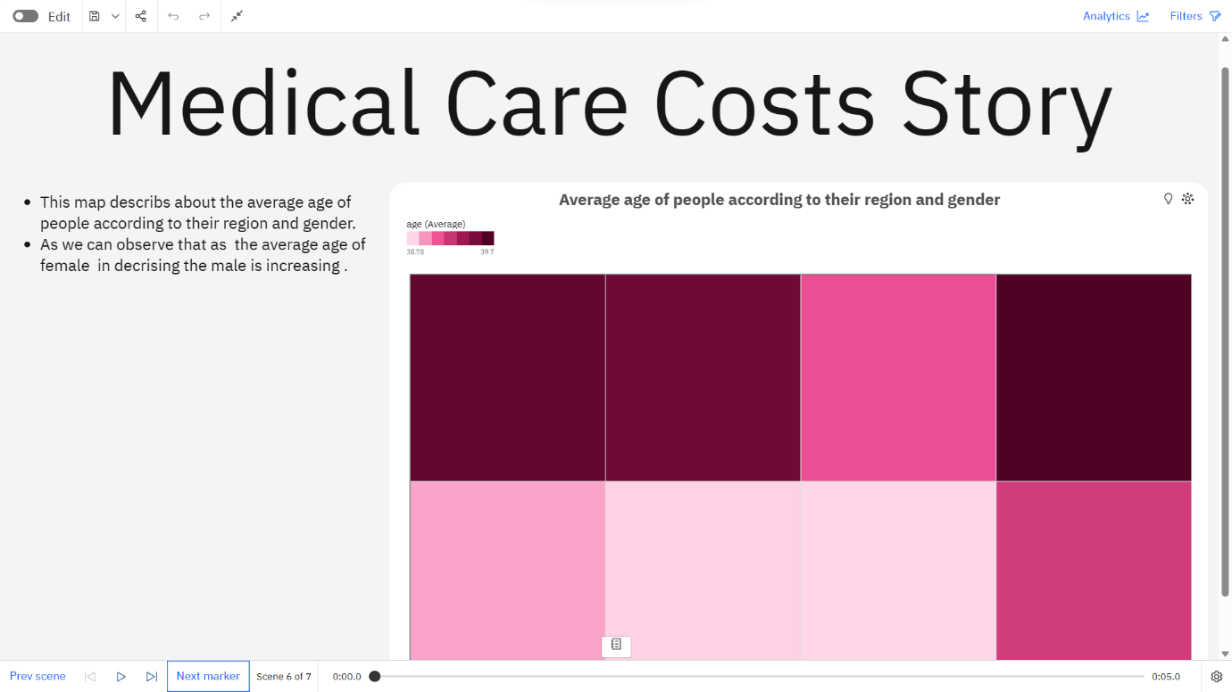

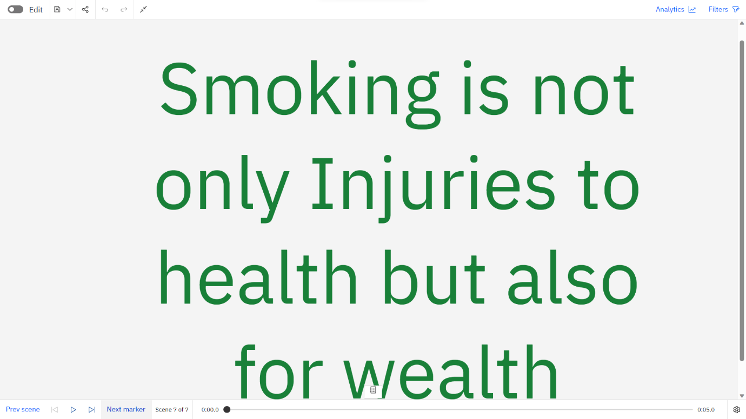

**5.ADVANTAGES AND DISADVANTAGES**

**Advantages:-**

* Cost optimization.
* Informed decision-making.
* Improved patient care.
* Tailored insurance coverage.
* Fraud detection.
* Refresh and policy development.

**Disadvantages:-**

* Data privacy concerns.
* Data quality.
* Model complexity.
* Limited predictability.
* Ethical considrations.
* Overemphasis on costs.

**6.APPLICATION**

* RESORCE ALLOCATION:-

Healthcare facilities , such as hospitals ansd clinics , can use cost estimation and prediction models to allocate resources effectively. By forcasting patient hospitalization and medical care costs, they can plan their budgets, stating and supply requirments more efficiently.

* HEALTH INSURANCE PLANNING:-

Insurance companies can utilize cost prediction models to develop and adjust insurance plans , premiums and coverage. Accurate cost estimation helps in setting appropriate premiums for difference policy holders , ensuring the financial sustainability of the insurance company.

* PUBLIC HEALTH POLICY:-

Government health agencies can leverage cost estimation and prediction data to shape public health policies and interventions. By understanding the financial burden of specific diseses (or) medical conditions , policymakers can allocate resourses and prioritize health programs effectively.

* CLINIC DECISION-MAKING :-

For physicians and healthcare providers , knowing the estimated costs of different treatments options can help them make informed decisions in collabrations with their patients. This allows patients to consider both medical efficiency and financial implications when chossing a course of treatment.

* COST-EFFECTIVENSS ANALYSIS:-

Researchs and policymakers can conduct cost effectiveness analyses for various healthcare interventions and treatments. By comparing the estimated costs of different treatments with their potential outcomes , they can identify the cost-effective strategies to improve patient care.

* BUDGET PLANNING FOR RESEARCH INSTITUTIONS:-

Medical reserch institutions often grants and funding for their projects. Cost estimation helps these instiutions plan their budgets accurately and allocate resources for the research endeauours effectively.

**7.CONCLUSION**

In conclusion,the estimation and prediction of hospitalization and medical are costs are crucial process that play a significant role in healthcare planning , resources allocation and financial management. By leveraging historical data , advanced statistical models and machine learning algoithms , healthcare organizations and policymakers can make informed decsions and create effective strategies to address the challenges posed by rising the medical expenses.

**8.FUTURE SCOPE**

The future scope of the estimation and prediction of hospitalization and medical care costs project is vast and holds great potential in transforming the healthcare industry.

Overall , the future scope of the estimation and prediction of hospitalization and medical care costs project is dynamic and transformative.

As technology continuous to evolve and data driven decision-making becomes increasingly prvelant, the projects applications have the potential to the revelotionize healthcare cost management , resouces allocation , and patient care on a global scale.

They are several future scopes for improving these process.

1. PREDIVTIVE ANALYTICS:-

Future systems can leverage predictive analytics to identity high-risk patients who may require frequent hospitalization (or) expensive medical interventions . By intervening early and providing fargeted care , healthcare provides can potentially reduce costs and improves patient outcome.

1. BLOCKCHAIN TECHNOLOGY:-

Blachchain can enchance the security and privacy of patient data , enabling seamlen and secure sharing of medical information among healthcare providers. By having access to comprehensive patient histories, hospitals can make more accurate cost estimates and avoid unnecessary duplicate tests(or) treatments.

1. POPULATION HEALTH MANAGEMENT:-

Adopting population health management stratagies can help healthcare organizations odentify trends and patterns in specific demographic groups. This information can be used to estimate the potential costs associated with managing, the health of different populations , allowing for better resource allocation.

1. SOCIAL DETEMINATION OF HEALTH:-

Includind social determinants of health , such as living conditions socioeconomic factors , and access to resoources, in cost estimation models can provide a more comprehensive understanding of patients needs and potential costs.